**Challenge 1:** Determine the IP address for codepath.com and use tcpdump to display packets with that IP as the destination. Then open <http://www.codepath.com> in the browser and check the output. Notice the output displays the HTTP requests in addition to the packets.

* How many requests to load the main codepath.com page? **9.**
* What type of resource accounts for most of the requests? **ICMP echo**.

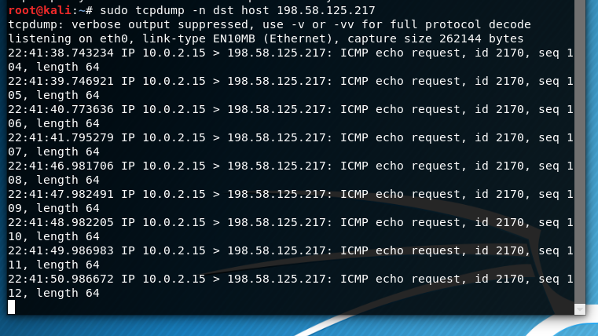

* Now try the same exercise with <https://security.codepath.com>. What differences do you see in the output? **I’m getting no information security.codepath.com.** What accounts for those differences? **No accounts after running command.**

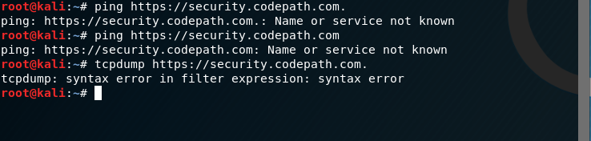

**Challenge 2:** You can also monitor DNS queries on port 53 with tcpdump. Use this to determine the IP of your primary DNS:

* Listen for DNS queries on port 53: sudo tcpdump -vvv -s 0 -l -n port 53
* Think of a domain name that probably exists (common word or phrase + .com) but that you've never visited before (suggestion: zombo.com) and open it in a browser
* Look at the tcpdump output for the UDP packets trying to resolve the domain. The destination IP should be the DNS.

